EDGE INTELLIGENCE LABORATORY
ASSIGNMENT 8
Krithana A
25MML0054

1) On-Device Image Recognition
1. Live Video Checking from Laptop Camera
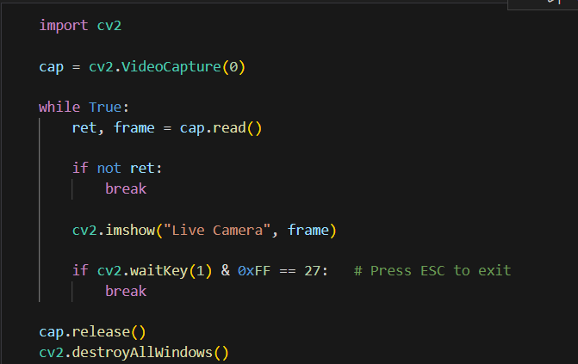
2. Capturing Live Video from Camera
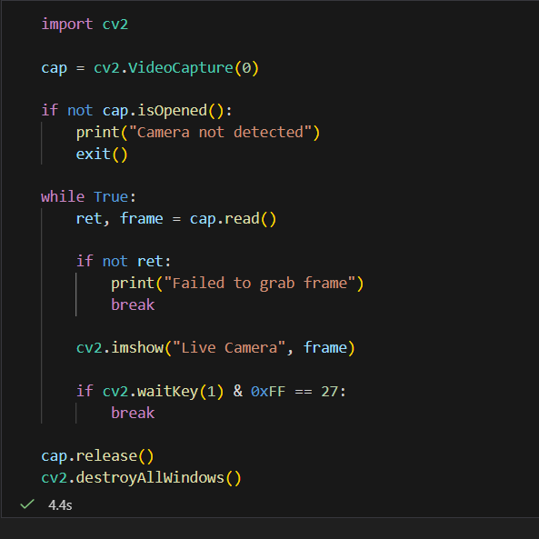

3. Live Video Edge Detection using Canny
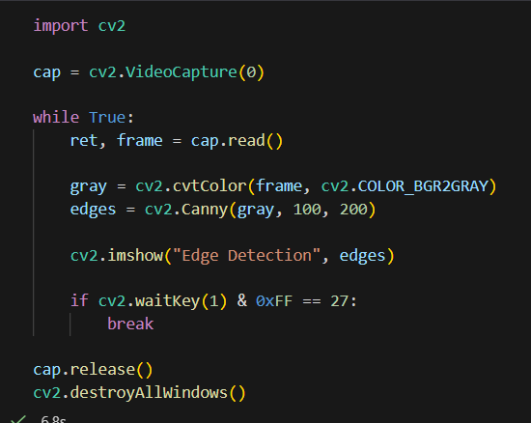
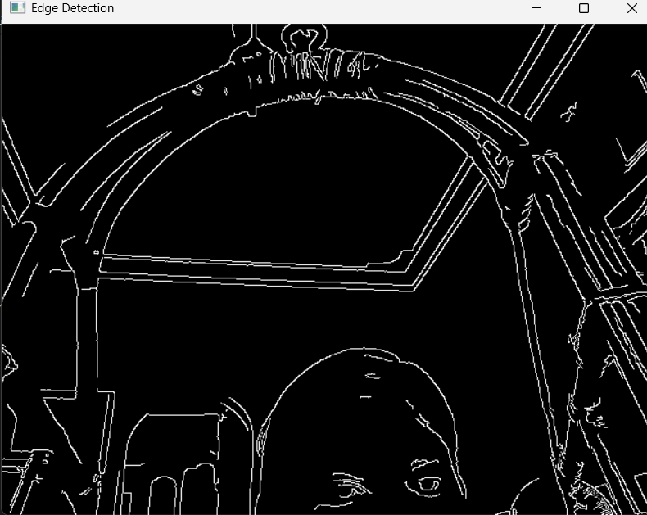

4. Convert Live Video to Canny Edge

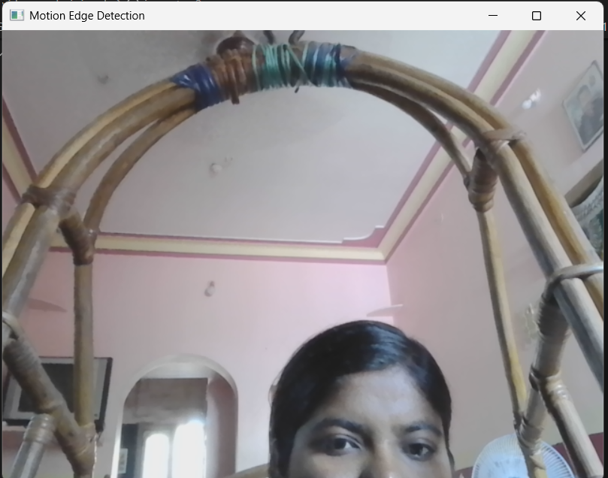


4. Motion Detection with Edge Output
No movement:
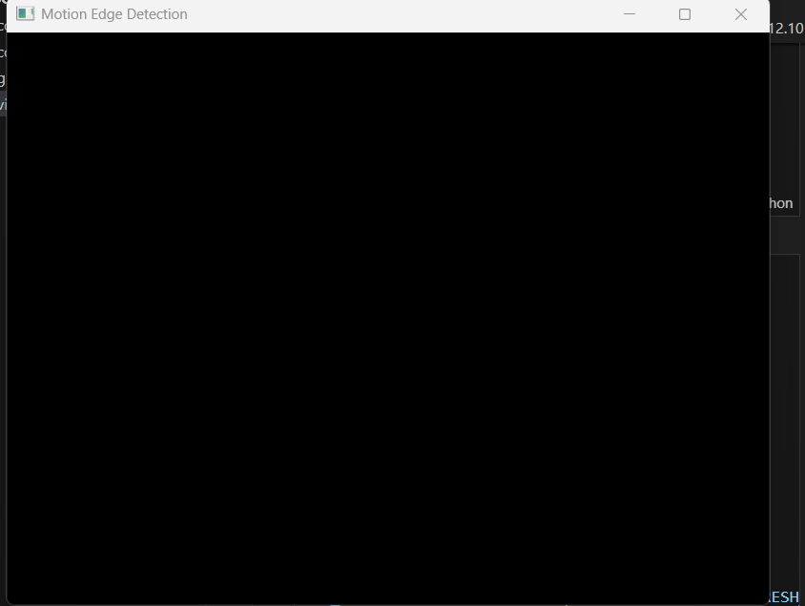
Movement:
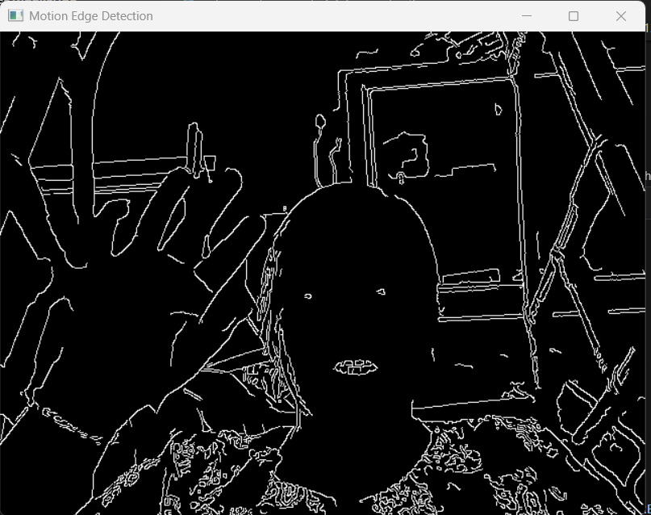
Insights
1. Live Video Checking from Laptop Camera
This task demonstrated how a laptop webcam can be accessed and used to capture live video streams. By continuously reading frames from the camera, OpenCV allows real-time visualization and processing of video data. This forms the foundation for many computer vision and Edge AI applications.
2. Capturing Live Video from Camera
The experiment showed how live video streams can be recorded and stored as video files. By using video writer functions, the captured frames are saved sequentially to create a video output. This is useful for surveillance systems, video logging, and later analysis.
3. Live Video Edge Detection using Canny
Applying the Canny edge detection algorithm to live video frames helps identify object boundaries and structural features in real time. Edge detection reduces image complexity while preserving important information, making it easier to detect shapes, objects, and movements.
4. Converting Live Video to Canny Edge
This task highlighted how each frame of a live video stream can be transformed into its edge representation. Converting the entire video feed into edge-detected frames provides a simplified visual representation that emphasizes contours and object outlines.
5. Motion Detection with Edge Output
Motion detection was implemented by comparing consecutive frames to identify significant changes. When motion is detected, edge detection is applied to highlight the moving objects, while no motion results in minimal or no processing. This approach demonstrates an efficient Edge AI technique where processing is triggered only when activity occurs.

2) Number Plate Detection System

Abstract
This report describes the design and implementation of a backend microservice that manages remote file operations using the File Transfer Protocol (FTP). The system is built using the Spring Boot framework and exposes RESTful APIs for uploading images, retrieving stored files, and dynamically archiving directories. The system also maintains a persistent audit log stored in a relational database.
In addition to file management, the service integrates a machine learning model and an OCR engine to automatically detect vehicle number plates and extract the alphanumeric characters from uploaded images. The detection process occurs in real time immediately after the image is uploaded to the server.
1. System Architecture and Technologies
The application follows a layered architecture consisting of three primary layers: the controller layer, service layer, and data access layer. This separation improves maintainability, scalability, and testing capability.

Backend Framework
The system is implemented using Spring Boot, which provides the infrastructure for REST API development, dependency injection, and automatic request handling.

Database and ORM
The system uses PostgreSQL as the relational database. Database interactions are handled through Hibernate and Spring Data JPA. Hibernate automatically creates and updates database tables using schema auto-generation.

FTP Communication
File transfer operations are handled using the Apache Commons Net FTPClient library, which provides low-level communication with the FTP server. It enables file uploading, directory navigation, and remote file storage.

Machine Learning and OCR
A machine learning detection model is used to identify the region containing the vehicle number plate. Once the plate area is detected, an OCR engine processes the cropped region and extracts the text characters.
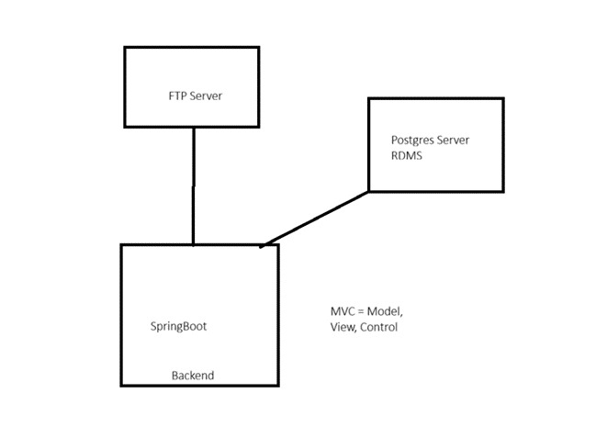
Figure 1: System Architecture — SpringBoot, FTP Server, and PostgreSQL
2. System Workflow
The system processes uploaded images through several stages.

Step 1 – Image Capture
A client application such as a mobile app, camera system, or web interface captures an image of a vehicle. The image is sent to the backend through a REST API request.

Step 2 – API Controller
The controller receives the request and performs validation checks including file format validation, file size verification, and validation of the FTP destination path provided through request headers.

Step 3 – Service Layer Processing
The service layer contains the core business logic. It generates metadata such as a unique filename and timestamp, verifies connectivity with both the FTP server and the database, and prepares the directory structure on the FTP server.

Step 4 – FTP File Storage
The uploaded image is stored on a centralized FTP server. If the required directory structure does not exist, the system automatically creates the necessary folders.

Step 5 – Machine Learning Detection
Once the file is stored, the ML detection model processes the image to identify the number plate region. The model highlights the detected region with a bounding box.

Step 6 – OCR Processing
The cropped number plate region is passed to the OCR engine, which converts the characters into machine-readable text.
Example output:
Detected Plate Number: KL07AB1234

Step 7 – Database Logging
Each successful upload is recorded in the PostgreSQL database as an audit log entry. The stored information includes filename, remote storage path, and upload timestamp.

Step 8 – Response to Client

After processing, the server sends a JSON response back to the client containing the detected plate number and processing status.
Example response:
{
"plate_number": "KL07AB1234",
"status": "success"
}

3. Windows FTP Server Setup
A local FTP server environment was configured using Internet Information Services (IIS) on Windows.
The FTP server role and FTP extensibility features were enabled through Windows features. A new FTP site was created in IIS Manager with the name EdgeFTP, configured to operate on port 21 with Basic Authentication enabled.
The FTP server directory was mapped to the physical path:
D:\FTP Shared
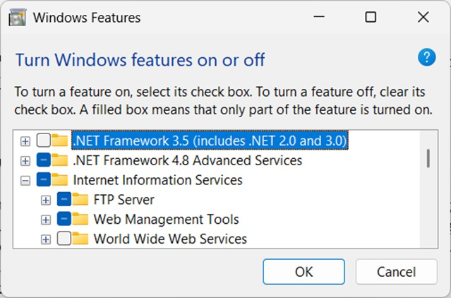
Figure 2: Enabling FTP Server role under Internet Information Services in Windows Features

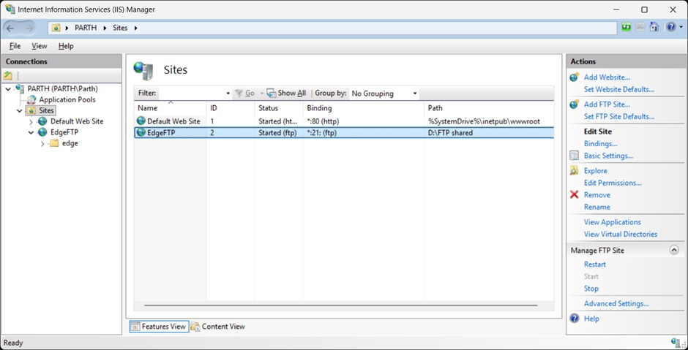

Figure 3: IIS Manager showing the EdgeFTP site running on port 21
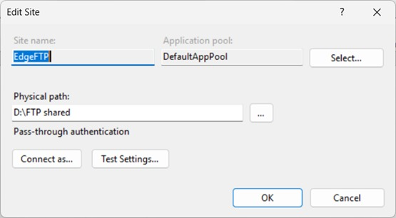
Figure 4: Edit Site dialog — EdgeFTP site configuration with physical path D:\FTP shared
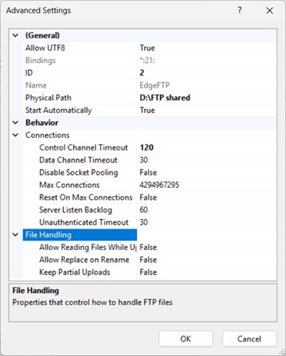
Figure 5: FTP Advanced Settings — connection timeouts and file handling properties

Since IIS FTP authentication relies on Windows user accounts, a dedicated local user account was created to handle FTP access. The necessary authorization rules were configured in IIS Manager to grant this user read and write permissions.
Additionally, NTFS file permissions were modified to give the user full control over the storage directory. This ensured that the backend application could successfully upload and retrieve files from the FTP server.
4. Detailed Workflow

Client Request
The user uploads a vehicle image through the API endpoint:
POST /api/ftp/detect
A custom header specifies the remote FTP directory where the file will be stored.

API Processing
The controller validates the uploaded file and ensures that the required request headers are present.
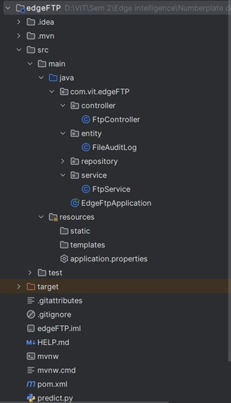
Figure 6: Spring Boot project structure — FtpController, FtpService, FileAuditLog entity

Business Logic Execution
The service layer generates metadata and constructs the FTP directory structure if it does not already exist.

FTP Upload
The image is uploaded to the remote FTP server and stored in the appropriate directory.

ML Model Execution
The machine learning model scans the image and identifies the vehicle number plate region.

OCR Text Extraction
The OCR engine converts the characters in the detected plate region into digital text.

Database Logging
A record of the uploaded file is stored in the database.

Field | Description
file_name | Original name of the uploaded image file
remote_path | The path on the FTP server where the file was saved
upload_time | Precise timestamp of when the file was successfully uploaded
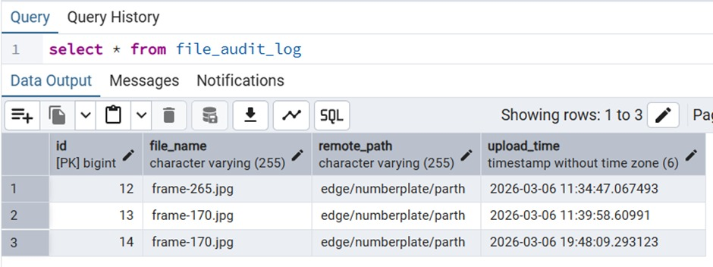
Figure 7: PostgreSQL file_audit_log table showing uploaded file records with timestamps
Hibernate automatically generates and executes the required SQL insert statement:
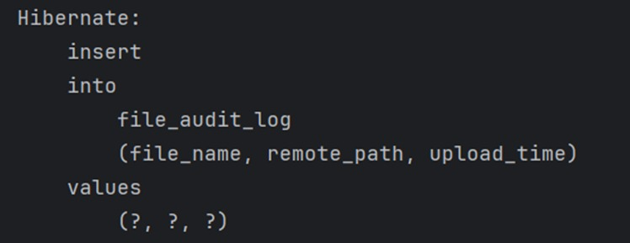
Figure 8: Hibernate-generated SQL insert statement for FileAuditLog

5. Core API Endpoints

1. File Upload and Plate Detection
POST /api/ftp/detect
This endpoint accepts an image file and processes it through the detection pipeline. The system automatically creates required directories, uploads the image, performs plate detection, and stores the audit log.
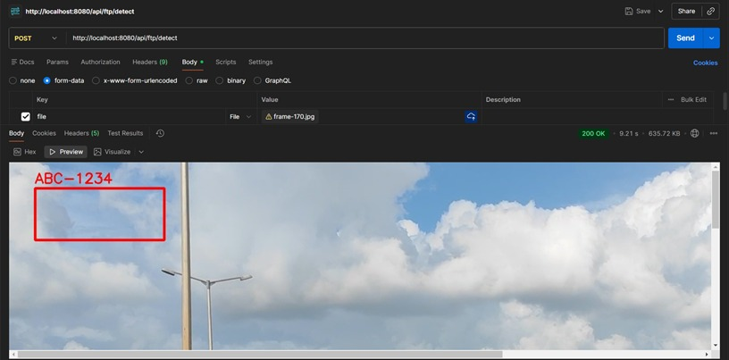
Figure 9: POST /api/ftp/detect — detection result showing bounding box with label ABC-1234
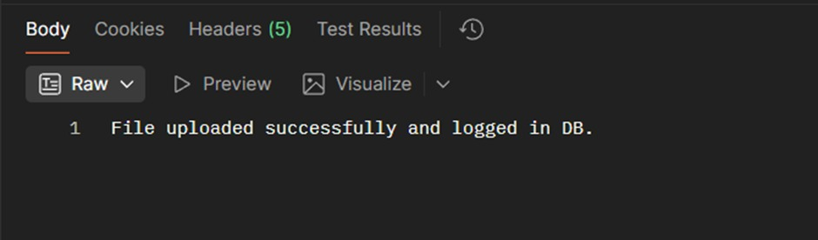
Figure 10: API success response confirming file upload and database log entry
2. Image Retrieval
GET /api/ftp/download/image
This endpoint retrieves a specific image from the FTP server and streams it directly to the client.
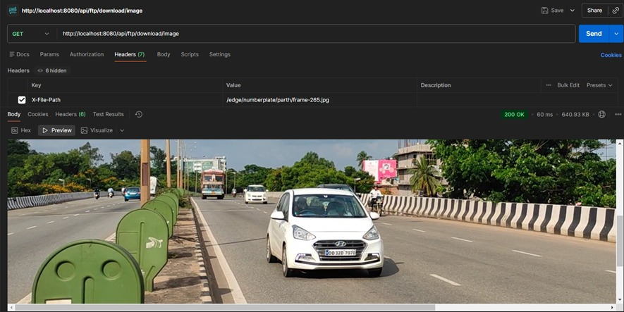
Figure 11: GET /api/ftp/download/image — retrieving and streaming an image from the FTP server

3. Folder Archive Download
GET /api/ftp/download/zip
This endpoint compresses the contents of a remote FTP directory into a ZIP file and streams it to the client without storing intermediate files on the server.
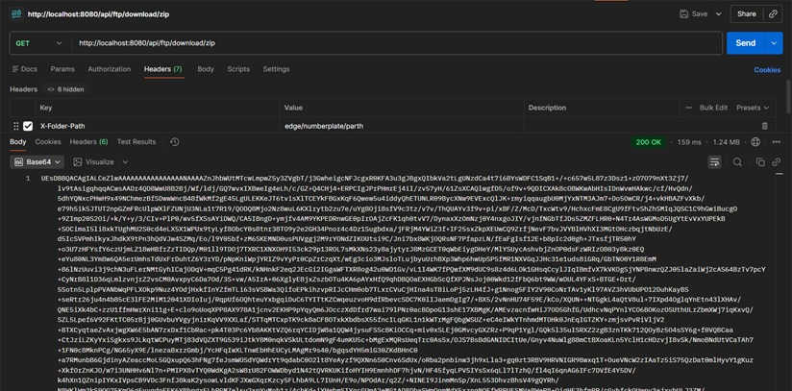
Figure 12: GET /api/ftp/download/zip — streaming a zipped archive of the FTP folder to the client
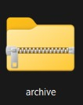
Figure 13: Downloaded .zip archive file

6. Technical Challenges

FTP Directory Navigation
One of the major challenges was managing FTP directory traversal when creating nested directories.
Solution:
The system resets the FTP working directory to the root before constructing the directory path. This ensures consistent navigation during file uploads.

FTP Authentication Issues
The IIS FTP server requires authentication using Windows system accounts.
Solution:
A dedicated Windows user account was created and assigned the necessary permissions in both IIS authorization settings and the NTFS file system.

7. Deployment
The backend application is packaged as an executable JAR file.
The system can be started using the command:
java -jar number-plate-detection.jar
During startup, the application initializes the Spring Boot server, connects to the PostgreSQL database, configures the FTP connection, and activates all API endpoints.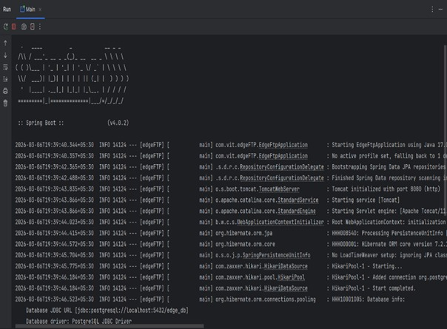
Figure 14: Spring Boot startup log showing successful server initialization and database connection
8. Technologies Used
Technology | Purpose
Spring Boot | Backend framework and REST API development
Apache Commons Net | FTP communication and file transfer
IIS FTP Server | Remote file storage server
Machine Learning Model | Detection of number plate region
OCR Engine | Extraction of plate text
PostgreSQL | Storage of audit logs
Hibernate / JPA | Object-relational mapping

Conclusion
The developed system provides a scalable backend microservice capable of integrating file storage, machine learning detection, and database logging into a unified architecture. By combining REST APIs, FTP storage, number plate detection, OCR processing, and audit logging, the system enables efficient real-time vehicle identification. The use of Spring Boot, PostgreSQL, FTP services, and machine learning technologies ensures high performance and the ability to support multiple concurrent users.

